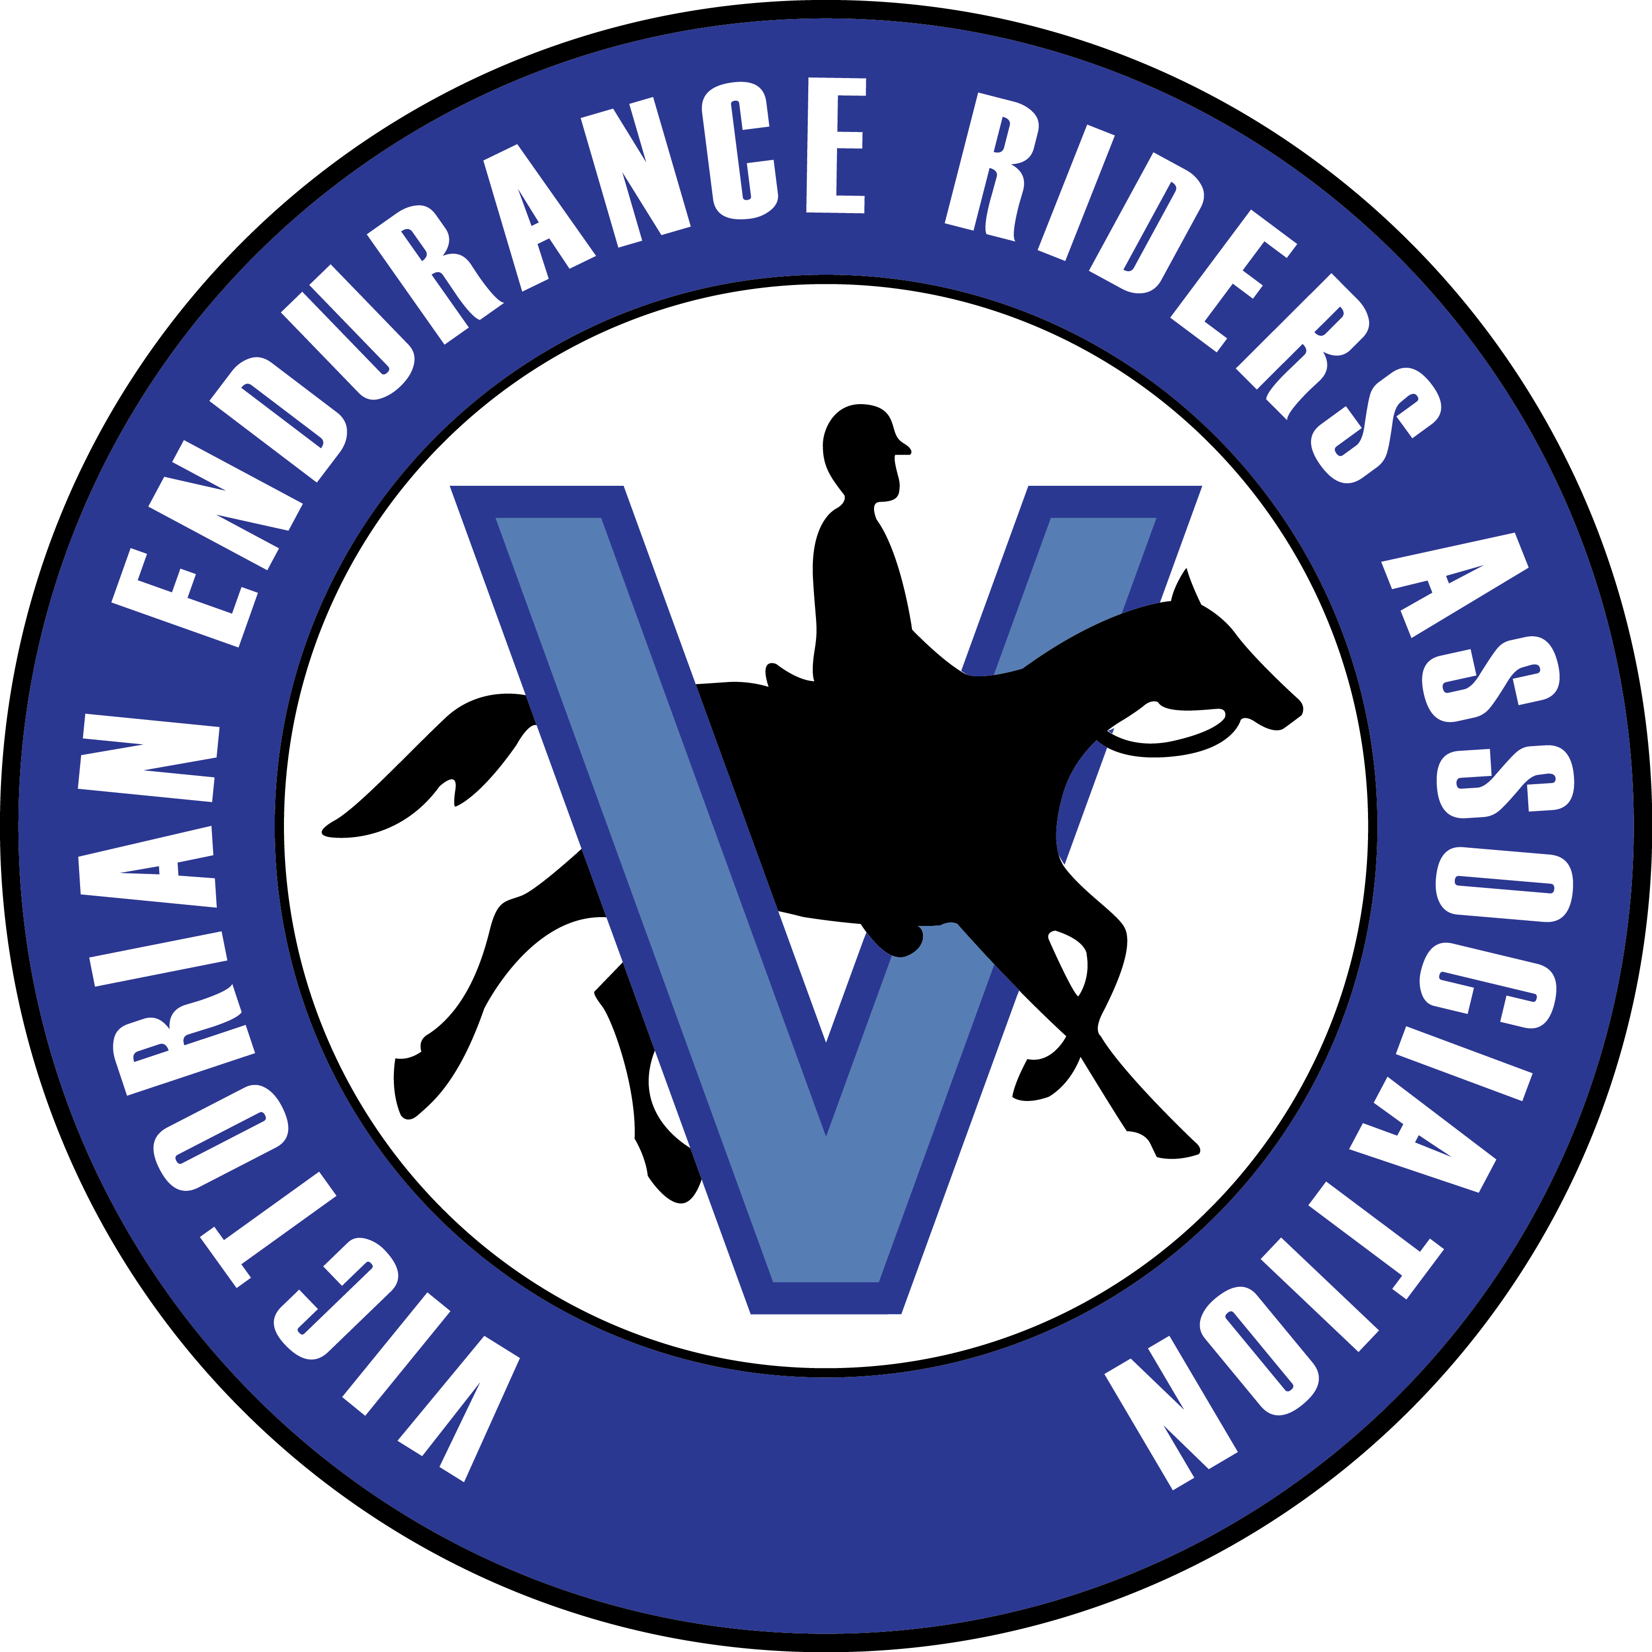
Ownership of the Endurance Horse 2024
TRANSFER OF HORSE OWNERSHIP
It is important that the correct person be registered as the owner of the endurance horse to assist in the allocation of National and State Distance and Point Scoring awards as well as identified as the persons responsible for the horse should Disciplinary Action need to be instituted.
Process for Changing Ownership Details:
When the sale of a horse issued with an AERA Logbook, it is the RESPONSIBILITY OF THE PURCHASER to notify their state body of the change of ownership.
A Transfer of Ownership form must be completed and forwarded to your State Logbook Registra, together with the logbook and fee.
FEE of $35 (payable to VERA Inc.)
Note: the logbook must accompany this Ownership Transfer form.

Return form, logbook and fee to Bronwyn Cuthbertson
138 Ercildoune Rd, Trawalla, 3373
Email: logbooks@vicera.com.au
Payment: Direct Deposit: Bendigo Bank BSB: 633000 ACC: 155253438

- Logbooks will not be delivered to rides.
- Standard: allow 15 days for return of logbook.
- Logbooks will be mailed once payment confirmed.
- Note – all logbooks with be returned by express post

HORSE DETAILS
Name: |  | Logbook No:
VENDOR DETAILS
Name(s): |  | Membership No:
Address: |  | Postcode:
PURCHASER DETAILS
Name(s): |  | Membership No:
Address: |  | Postcode:
PICC where Horse will Reside:
I/We acknowledge that the AERA/VERA Inc. will rely on the information provided in this document which I/We state to be true, accurate and complete to the best of my/our knowledge.
Vendor Signature: |  | Date:
Purchaser Signature: |  | Date:
Witness Signature: |  | Date:
Witness Name (print)

