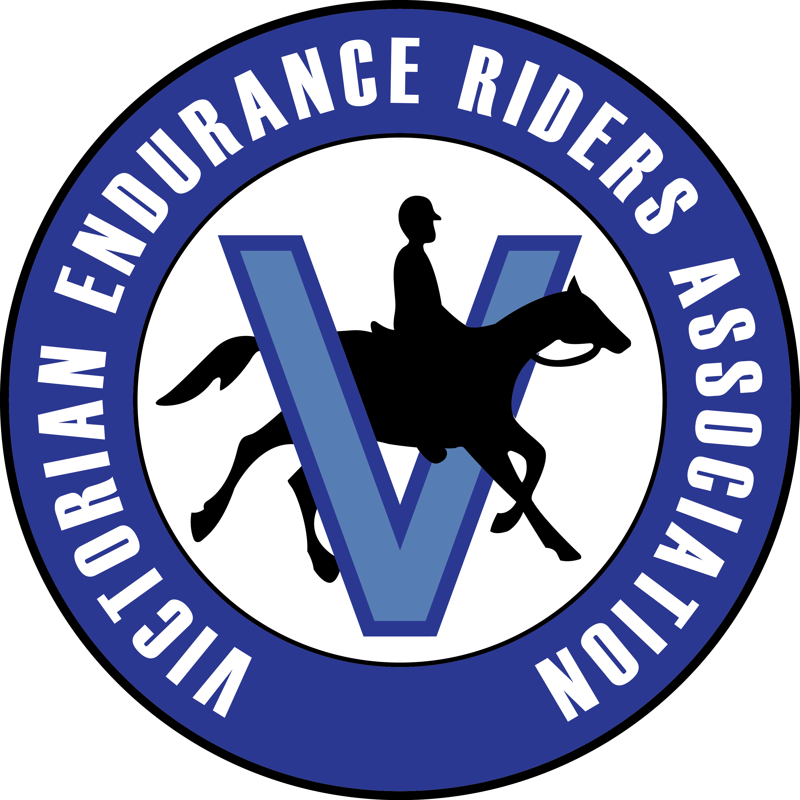
NOVICE & ENDURANCE HORSE LOGBOOK APPLICATION 2024
NOVICE HORSE LOGBOOK (BLUE)
Complete all 3 pages of form. The Horse ID may be completed by the legal owner, or applicant or a registered Veterinarian.
DO NOT pay the AERA endurance horse registration.
ENDURANCE HORSE LOGBOOK (YELLOW)
Endurance Horses MUST have the following
- Successful completion of at least 240km in affiliated rides.
- Veterinarian ID and be microchipped.
NOTE: If anaesthetic used for microchip insertion, horse cannot compete at an AERA affiliated event for 6 days following insertion.
- AERA Endurance Horse Registration – Annual or Lifetime.
NOTE: An endurance horse logbook will not be issued until 90 days from the date of the first affiliated endurance ride that the horse successfully completes.
- Logbooks will not be delivered to rides.
- Standard: allow 15 working days for return of logbook.
- Logbooks will be mailed once payment confirmed.
- When emailing completed form, send as either PDF/Word file. Photos cannot be accepted.
NOTE – logbook application include plastic cover and return express post for each Horse Logbook
HORSE DETAILS Horse’s registered name MUST be used and copy of relevant breed registration provided
Name |  | Reg. No.
Sire |  | Reg. No.
Dam |  | Reg. No.
PIC number |  | DOB:
Horse address
APPLICANT DETAILS Log book applicant must be a current financial VERA member at the time of application
Applicant Name |  | M/ship No.
Address |  | Post Code
Email |  | Telephone
Signature: |  | Date:
LEGAL OWNER’S DETAILS If applicant is the legal owner write ‘as above’, OR include owner information
Owner Name |  | M/ship No.
Address |  | Post Code
Email |  | Telephone

Item | Fee | Total |  | Item | Fee | Total
Novice Logbook | $42.00 |  |  | AERA Endurance horse registration  (Yellow logbook only) | Annual $30.00
Upgrade to Endurance | $20.00 |  |  | AERA Endurance horse registration  (Yellow logbook only) | Lifetime $65.00
Replacement Logbook | $47.00 |  |  | Express fee (if required within 5 working days) | $30.00
Total amount payable |  |  |  | Total amount payable

Send proof of payment and application to: BRONWYN CUTHBERTSON
138 Ercildoune Rd, Trawalla, VIC 3373
email: logbooks@vicera.com.au
PAYMENT: Direct Deposit – Bendigo Bank: BSB: 633000: ACC:155253438
HORSE IDENTIFICATION– page 1 of 2
PAGE 1: HORSE IDENTIFICATION
Horse Name: |  | DOB: | / /
Microchip No: |  | Sex: | M G S
AGE OF THE HORSE ON THE
DAY OF IDENTIFICATION
______yrs

VETERINARIAN DECLARATION
I am a registered Veterinarian and certify that the information entered on this document is a true and accurate record of the horse named.
Vet Name: |  | Reg No:
Signature: |  | Date:
APPLICANT DECLARATION
I, the applicant, declare that the details of the horse specified in this Horse Logbook Application is a true and accurate record of the horse named.
Name: |  | M/ship No:
Signed: |  | Date:

HORSE IDENTIFICATION– page 2 of 2
PAGE 2: HORSE IDENTIFICATION
Horse Name:
Microchip No: |  | Sex: | M G S
Date of Birth: |  | Breed:
Colour: |  | Height:
MARKINGS
Head & Neck
Left Fore
Right Fore
Left Hind
Right Hind
Body
Brands & Acquired Markings

VETERINARIAN DECLARATION
I am a registered Veterinarian and certify that the information entered on this two page document is a true and accurate record of the horse named.
Name |  | Reg. No.
Practice address |  | Phone No:
Signature |  | Date

APPLICANT DECLARATION
I, the applicant, declare that the details of the horse specified in this Horse Logbook Application is a true and accurate record of the horse named.
Name: |  | M/ship No:
Signed: |  | Date:

